**Project planning phase**

**(Product Backlog , Sprint Planning , Stories , Story Points)**

|  |  |
| --- | --- |
| Date | 21 October 2022 |
| Team ID | PNT2022TMID36688 |
| Project Name | Deep Learning Fundus Image Analysis for early Detection of Diabetic retinopathy. |

**Product Backlog, Sprint Schedule, and Estimation.**

To create product backlog and sprint schedule.

|  |  |  |  |  |  |  |
| --- | --- | --- | --- | --- | --- | --- |
| **Sprint** | **Functional Requirement(Epic)** | **User Story Number** | **User Story/Task** | **Story points** | **Priority** | **Team Members** |
| Sprint-1 | Registration | USN-1 | As a user, I can register for the application by entering my email or phone number and password, and conforming my password. | 10 | High | Madanambeti Bharath |
| Sprint-1 | Dashboard | USN-2 | As a user, I will Redirected to the dashboard after registration which shows the importance of DR. | 10 | Medium | N. Gajala  &  Madanambeti Bharath |
| Sprint-2 | Login | USN-3 | As a user, I can log into the application by entering login credentials. | 5 | High | C .Kumar |
| Sprint-2 | Upload images | USN-4 | As a user, I should be able to upload the image of eye Retina. | 10 | High | R. Jayasri |
| Sprint-2 | Dashboard | USN-5 | As user, based on my requirement I can navigate through the dashboard. | 5 | Medium | B. Sandhiya |
| Sprint-3 | Train the model | Task 1 | As developer, the dataset will be uploaded and trained by developed algorithm. | 20 | High | R. Jayasri |
| Sprint-4 | Testing & Evaluation | Task 2 | As a developer, we tested the trained model using the provided dataset and model will be evaluated for accurate results. | 10 | High | N. Gajala |
| Sprint-4 | Display predicted result | USN-6 | As a user, I can view the predicted result in the dashboard. | 10 | High | R.Jayasri |

**Project Tracker, Velocity & Burndown chart :**

|  |  |  |  |  |  |  |
| --- | --- | --- | --- | --- | --- | --- |
| **Sprint** | **Total Story Point** | **Duration** | **Sprint Start Date** | **Sprint End Date (Planned)** | **Story Points Completed (as on planned end date)** | **Sprint Release Date (actual)** |
| Sprint-1 | 20 | 6 Days | 24 Oct 2022 | 29 Oct 2022 | 20 | 29 Oct 2022 |
| Sprint-2 | 20 | 6 Days | 31 Oct 2022 | 05 Nov 2022 | 20 | 05 Nov 2022 |
| Sprint-3 | 20 | 6 Days | 07 Nov 2022 | 12 Nov 2022 | 20 | 12 Nov 2022 |
| Sprint-4 | 20 | 6 Days | 14 Nov 2022 | 19 Nov 2022 | 20 | 19 Nov 2022 |

**Velocity:**

Imagine we have a 10-day sprint duration, and the velocity of the team is 20 (points per sprint). Let’s calculate the team’s average velocity (AV) per iteration unit (story points per day). 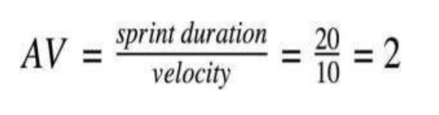

AV = 20/6 = 3.33 points per day

**Burn Down Chart & JIRA :**

A burn down chart plots the amount of work remaining to perform against the amount of time. In agile software development approaches like Scrum, it is frequently employed. Burn down charts, however, can be used for any project that makes observable progress over time.

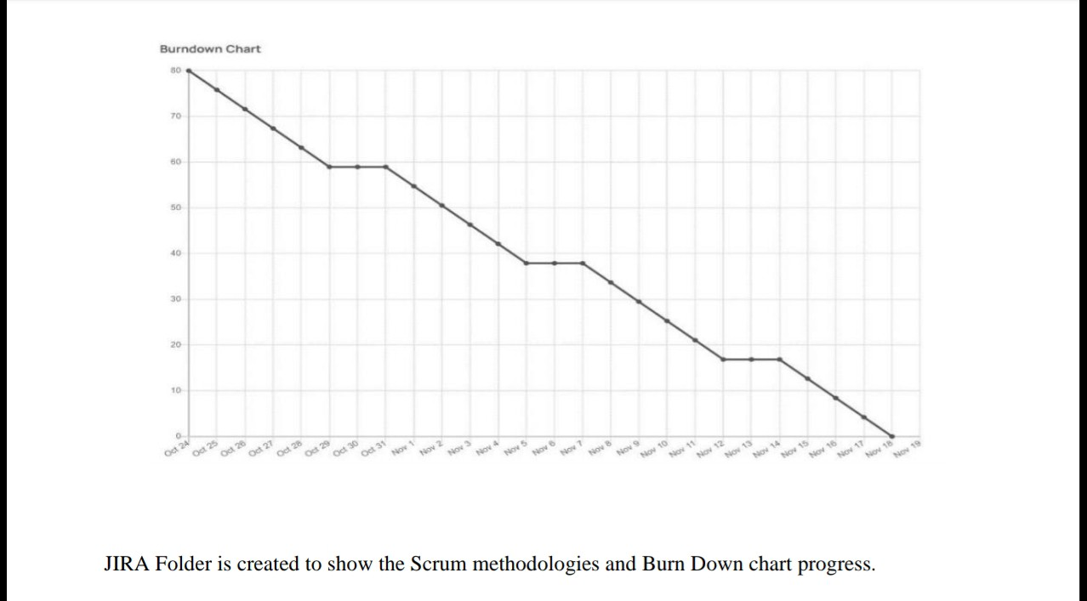

JIRA Folder is created to show the Scrum methodologies and burn down chart progress.